PROJECT
On

Synthetic Data Generation and Evaluation
Using Machine Learning on the Pima Indians Diabetes Dataset
In
Software Tools for Artificial Intelligence and Machine Learning
BACHELOR OF TECHNOLOGY
IN
Artificial Intelligence and Machine Learning
SUBMITTED BY
NAME : PRN:
Snigdha Singh | 25070126169
Shubhayu Bhattacharya | 25070126168
Shaury Tandon | 25070126162
Sohan Saha | 25070126170


Under the Supervision of
Dr. Priyanka Deshmukh, Professor
SYMBIOSIS INSTITUTE OF TECHNOLOGY, PUNE - 412115
(A CONSTITUENT OF SYMBIOSIS INTERNATIONAL (DEEMED UNIVERSITY))
2025-26

1. Abstract
This project looks at a genuinely practical problem in healthcare research. Medical datasets are useful for training AI models but they contain sensitive patient information that cannot be freely shared. The question we tried to answer is whether it is possible to generate artificial data that statistically resembles real patient records closely enough to train a working machine learning model, without ever using real patient information in the output.
We used the Pima Indians Diabetes Dataset as the starting point. It has 768 patient records with eight clinical measurements and a diabetes diagnosis label. The project ran through a complete data pipeline covering missing value handling, outlier detection, exploratory analysis, label encoding, and finally generating 500 synthetic patient records using Gaussian statistical sampling. Two classifiers, Logistic Regression and Random Forest, were each trained twice, once on real data and once on the synthetic version, and tested on the same held-out real test set.
The accuracy gap between the two conditions was small for Logistic Regression and moderate for Random Forest, which tells us that Gaussian sampling works reasonably well for simpler models and leaves room for improvement with more complex generation techniques like CTGAN or diffusion models.

2. Introduction

Anyone who has tried to do serious research using healthcare data will tell you that getting hold of it is the hard part. The data exists, hospitals and clinics collect it constantly, but sharing it is a different matter entirely. Privacy regulations, institutional sign-offs, ethics reviews, and data sharing agreements can take months to navigate and sometimes fall through completely. Researchers often end up stuck with whatever public datasets happen to be available.
Synthetic data is one of the more promising answers to this bottleneck. The basic idea is that instead of sharing actual patient records, you build a statistical picture of what those records look like and then generate new artificial records that follow the same patterns. The artificial patients do not exist, so there is nothing to protect, but the data they produce still carries enough statistical structure to be useful for training and testing models.
This project applies that idea to the Pima Indians Diabetes Dataset, a well-known benchmark collected by the National Institute of Diabetes and Digestive and Kidney Diseases. The dataset covers 768 female patients of Pima Indian heritage and records eight clinical measurements alongside a binary diabetes outcome. The whole pipeline was built in Python using standard libraries: pandas, numpy, sklearn, matplotlib, and seaborn.
The central question is whether a machine learning model trained entirely on synthetic data can produce results comparable to one trained on real patient records. If the answer is yes, it suggests synthetic generation is a viable tool for privacy-preserving research in healthcare and other sensitive domains.

3. Literature Review
Before starting the actual work, we went through four research papers published between 2024 and 2025 that cover the landscape of synthetic data generation. These gave us a picture of what methods are currently being used, what the known limitations are, and how researchers are evaluating synthetic data quality. Short descriptions of each paper are given below, followed by a summary table.

Paper 1: A Systematic Review of Synthetic Data Generation Techniques Using Generative AI (2024)
Published in the Electronics journal by MDPI in September 2024, this paper reviewed 77 studies and mapped out the three main technologies being used to generate synthetic data: Generative Adversarial Networks, Variational Autoencoders, and Large Language Models. It was useful not just for describing the methods but for pointing out where each one falls short. GANs are powerful but expensive and unstable to train. LLMs are flexible but can produce values that look plausible but are medically wrong. The paper also confirmed that healthcare and finance are the two domains where synthetic data is being most actively adopted, which made it directly relevant to our project.

Paper 2: Comprehensive Exploration of Synthetic Data Generation: A Survey (2024)
This arXiv paper from January 2024 took a very wide view, cataloguing 417 different synthetic data generation models built over the past decade and sorting them by architecture and domain. The main finding was that neural network based approaches have taken over the field, with GANs being dominant for structured and visual data. What influenced our project most was their observation that there is still no universally agreed way to measure whether synthetic data is good. That pushed us toward the most interpretable evaluation possible, which is comparing model accuracy when trained on real data versus synthetic data and seeing how close the numbers are.

Paper 3: Generative AI for Synthetic Data Generation: Methods, Challenges and the Future (2024)
This March 2024 arXiv paper focused on using LLMs specifically to generate training data in situations where real data is scarce. The authors found that LLM-generated synthetic data could help models outperform baselines trained on small real datasets in several cases. More practically relevant for our project was their warning about hallucination in tabular medical data, where a model might produce a row with biologically impossible values. That is exactly why we clipped all generated values to the observed min and max range from the real dataset during synthetic generation.

Paper 4: Machine Learning for Synthetic Data Generation: A Review (2024-2025)
The most comprehensive of the four, this arXiv paper was updated through April 2025 and covers GAN variants like WGAN and CTGAN, diffusion models, VAEs, and reinforcement learning based generation across multiple domains including healthcare, NLP, and tabular data. The authors evaluated each method against fidelity, diversity, and privacy, and concluded that the tension between privacy and utility is the central unsolved problem in the field. That framing describes exactly what our project is demonstrating: the closer synthetic data is to the real data, the more useful it is, but also the more risk there is of it revealing something about the real records it was built from.

Title of Paper | Published Year | Dataset Used | Methodology Used in Existing Paper | Key Findings / Results
A Systematic Review of Synthetic Data Generation Techniques Using Generative AI | 2024 | 77 studies spanning healthcare, finance, NLP, and computer vision | Systematic literature review of LLMs, GANs, and VAEs for synthetic data generation across domains | GANs and LLMs most effective; diffusion models are emerging; privacy leakage remains a challenge
Comprehensive Exploration of Synthetic Data Generation: A Survey | 2024 | Survey of 417 SDG models built over the past decade | Classification of models by architecture and domain; trend analysis across SDG approaches | Neural network models dominate; GANs lead for structured data; no universal evaluation metric exists
Generative AI for Synthetic Data Generation: Methods, Challenges and the Future | 2024 | Low-resource NLP datasets for evaluating LLM-generated synthetic training data | Prompt engineering and fine-tuning pipelines for LLM-based synthetic data creation | LLM data matches real data in low-resource settings; hallucination in tabular data is a key risk
Machine Learning for Synthetic Data Generation: A Review | 2024-2025 | Multi-domain: EHR, NLP, computer vision (ImageNet, CIFAR), and tabular benchmarks | Review of WGAN, CTGAN, VAEs, diffusion models, RL-based synthesis; fidelity, diversity, privacy metrics used | GAN variants achieve highest fidelity; privacy-utility tradeoff is the central unsolved problem

4. Dataset Description

The dataset used throughout this project is the Pima Indians Diabetes Dataset, originally collected as part of a study by the National Institute of Diabetes and Digestive and Kidney Diseases. It covers 768 female patients from the Pima Indian community in Arizona, all aged 21 or older at the time of examination. Each row in the dataset represents one patient and contains eight clinical measurements taken at the time of the visit, along with a binary label that was recorded five years later indicating whether the patient was diagnosed with diabetes.
Of the 768 patients, 268 were eventually diagnosed with diabetes and 500 were not. This imbalance is worth noting because classifiers tend to perform better on the majority class, which shows up clearly in the confusion matrix results.
One data quality issue that had to be handled before anything else: several columns use 0 as a placeholder for a missing value rather than an actual measurement of zero. A blood pressure of 0, a glucose level of 0, or a BMI of 0 are not physiologically possible in a living person. The affected columns were Glucose, BloodPressure, SkinThickness, Insulin, and BMI. These were identified during inspection and handled through mean imputation in the preprocessing step.

Column | What it represents | Normal / Safe range
Pregnancies | Number of times the patient has been pregnant | 0 to 17
Glucose | Blood sugar level from a 2-hour glucose tolerance test (mg/dL) | 70 to 140 mg/dL
BloodPressure | Diastolic blood pressure in mm Hg | 60 to 80 mm Hg
SkinThickness | Tricep skin fold thickness used as a proxy for body fat (mm) | 10 to 40 mm
Insulin | 2-hour serum insulin level in mu U/ml | 16 to 166 mu U/ml
BMI | Body Mass Index, weight in kg divided by height in metres squared | 18.5 to 24.9
DiabetesPedigreeFunction | A score reflecting genetic likelihood of diabetes based on family history | 0.08 to 2.42
Age | Age of the patient in years | 21 to 81
Outcome | 1 if diabetes was diagnosed within 5 years, 0 if not | 0 or 1

5. Methodology

The project followed an eight-step pipeline. Each step fed into the next and each one corresponds to a concept from the STAIML lab manual.

Step 1: Data Acquisition
The dataset was loaded from a CSV file using pandas read_csv(). A df.head() call gave an initial look at column names, data types, and the first few rows, which was enough to spot the 0 value issue and plan the cleaning steps.

Step 2: Missing Data Handling
Each 0 in the five affected columns was replaced with NaN using numpy, and then filled with the mean of the remaining valid values in that column. This is mean imputation. It keeps all 768 rows in the dataset rather than dropping patients who had incomplete measurements.

Step 3: Outlier Detection
Boxplots were drawn for all eight features. Any value sitting more than 1.5 times the interquartile range above the third quartile or below the first quartile counts as an outlier by the IQR method. Insulin had the most extreme outliers in this dataset, with a handful of readings above 600. These were left in because very high insulin resistance can reflect a genuine clinical condition.

Step 4: Univariate Analysis
Histograms were plotted for each feature individually. Most showed a right skew, meaning most patients clustered toward lower values with fewer patients at the high end. Glucose and BloodPressure were closest to a symmetric bell-shaped distribution. Age was concentrated between 21 and 40.

Step 5: Bivariate Analysis
Two plots were used here. A correlation heatmap showed the pairwise relationship between all features and the Outcome label. Glucose came out with the strongest correlation to Outcome at around 0.47. A scatter plot of Glucose against BMI, coloured by class, showed a visible tendency for diabetic patients to appear at higher values on both axes.

Step 6: Encoding
The Outcome column was mapped to text labels and then converted back to numbers using sklearn's LabelEncoder. In this dataset the column was already numeric but going through this process explicitly demonstrates how categorical variables are handled before being passed into a model.

Step 7: Synthetic Data Generation
For each class separately, the mean and standard deviation of every feature were calculated from the real patient records in that class. New values were then sampled from a Gaussian distribution built on those parameters using numpy.random.normal(). Any value that landed outside the real data's observed minimum and maximum was clipped back into range. The process was repeated to produce 500 synthetic rows in total while maintaining the same class ratio as the original dataset.

Step 8: ML Model Training and Evaluation
Two models were used, Logistic Regression and Random Forest. Each was trained twice, once on real training data and once on the synthetic dataset, and both were evaluated on the same real held-out test set. StandardScaler normalised the features before training. Accuracy scores were compared across all four combinations and a confusion matrix was plotted for Random Forest.

6. Results & Discussion / Visualizations

6.1 Outlier Detection
The boxplots show the spread of each feature after imputation. Dots above or below the whiskers are outliers by the IQR definition. Insulin has the most extreme outliers by a significant margin. DiabetesPedigreeFunction also has a cluster of high-end values. The remaining features are comparatively well-behaved.
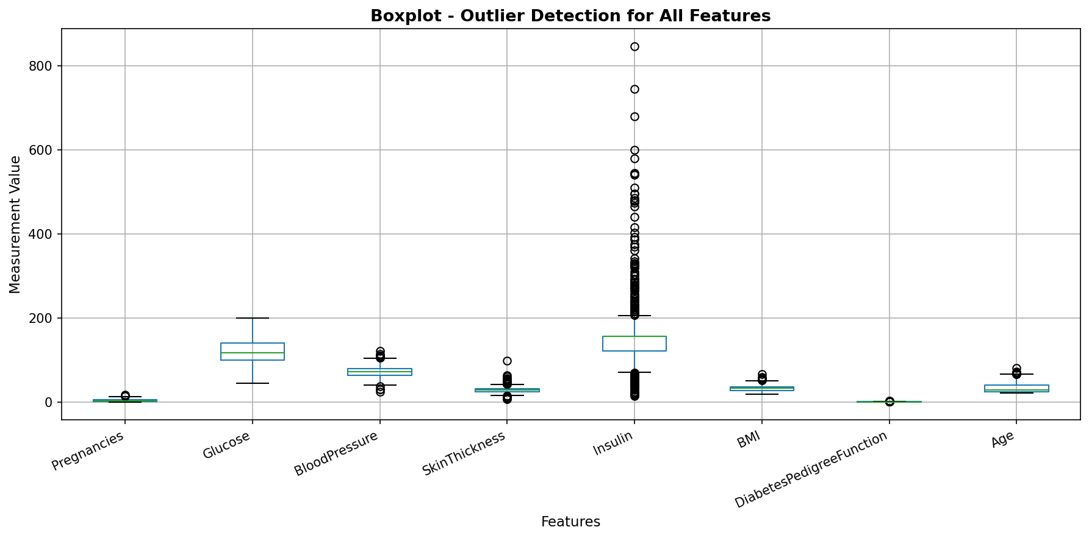
Figure 1: Boxplot showing outlier detection across all eight features

6.2 Univariate Analysis
Each histogram shows how one feature is distributed across all 768 patients. The Y-axis counts how many patients fall into each value range. Most features are right-skewed. Glucose is the closest to a normal distribution among the eight. The Age distribution shows the study sample skews younger, with most patients under 40.
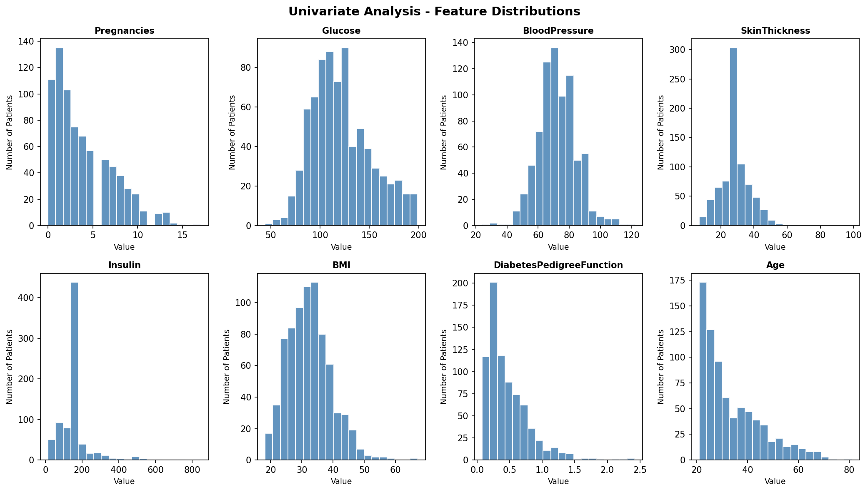
Figure 2: Histograms showing the distribution of each feature across all patients

6.3 Correlation Heatmap
The heatmap shows pairwise correlations between all eight features. Values toward 1.0 indicate a stronger positive relationship. Glucose has the highest correlation with Outcome at roughly 0.47. BMI and Age show moderate correlations around 0.29 and 0.24. Most feature pairs have weak relationships with each other, which suggests the features are capturing different aspects of the patient's condition.
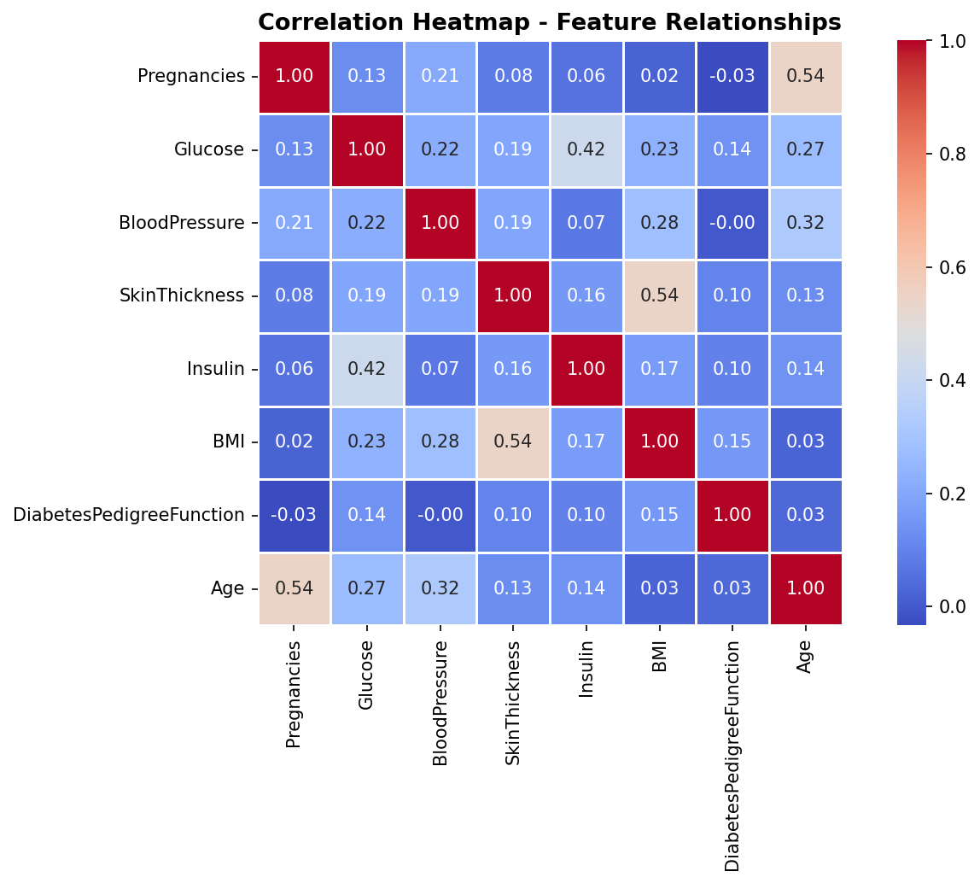
Figure 3: Correlation heatmap showing feature-to-feature and feature-to-outcome relationships

6.4 Glucose vs BMI Scatter
Each dot represents one patient. Blue dots are non-diabetic patients and red dots are diabetic. There is a noticeable shift toward the upper right for red dots, meaning higher glucose combined with higher BMI is associated with a greater chance of diabetes. The classes overlap quite a bit, which is why a trained model is needed rather than a simple threshold.
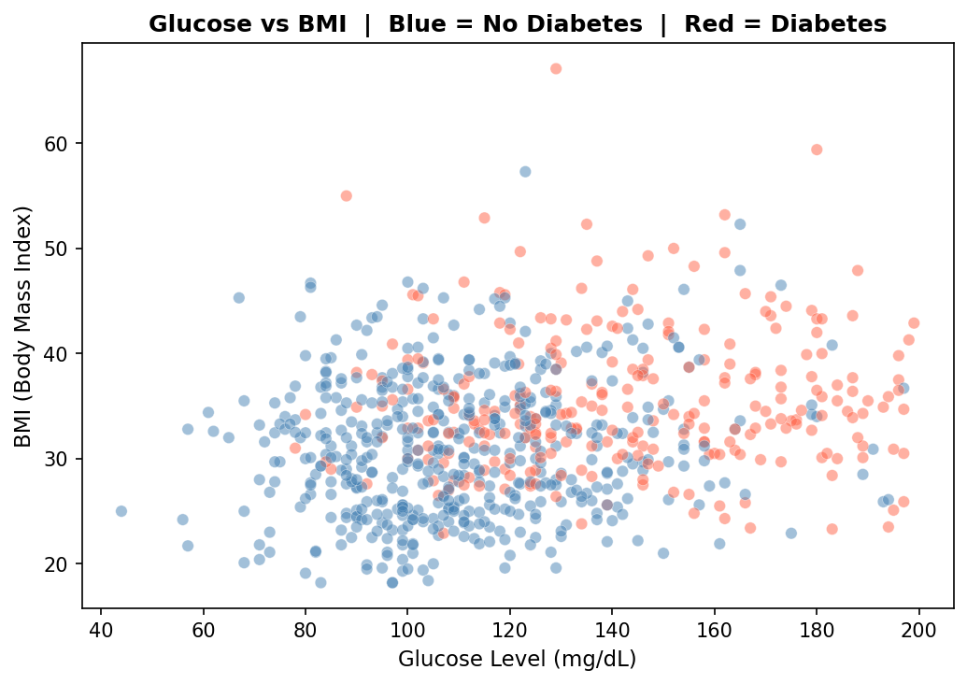
Figure 4: Scatter plot of Glucose vs BMI coloured by diabetes outcome

6.5 Real vs Synthetic Distribution Comparison
The overlapping histograms compare real data in blue against synthetic data in orange-red for the first four features. The closer the two shapes are the better the synthetic data is as a replacement. The overlap is strong for Glucose and BloodPressure. Pregnancies also matches well. SkinThickness shows a slight peak shift but the overall shape is similar. This level of visual agreement confirms the Gaussian sampling approach captured the statistical character of the original data.
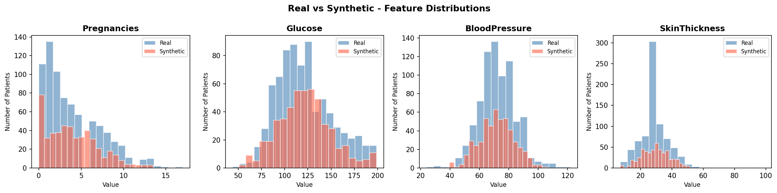
Figure 5: Overlapping distributions for real vs synthetic data across four features

6.6 Model Accuracy Comparison
The bar chart shows how each model performed when trained on real data versus synthetic data, both tested on the same real test set. The exact numbers are in the table below.
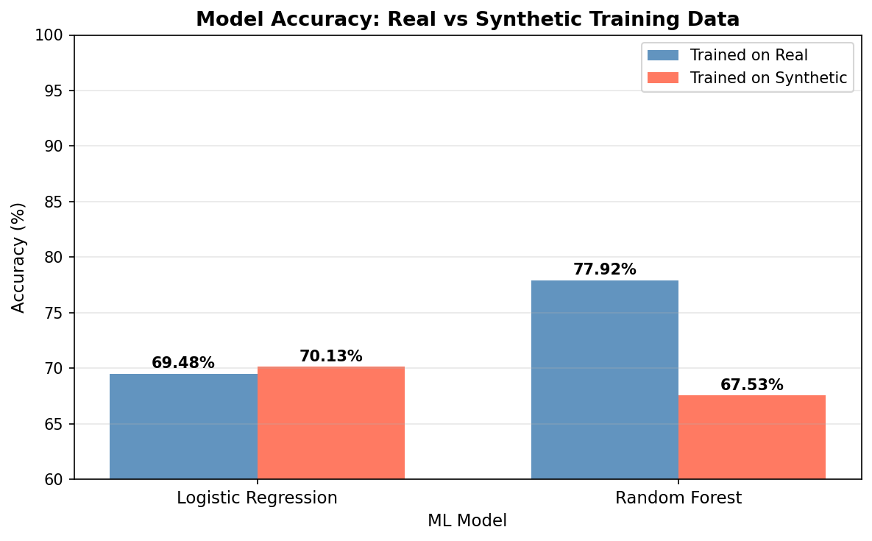
Figure 6: Model accuracy when trained on real data vs synthetic data

Model | Trained on Real | Trained on Synthetic
Logistic Regression | 69.48% | 70.13%
Random Forest | 77.92% | 67.53%

Logistic Regression performed almost identically under both training conditions, with the synthetic version slightly ahead. This is a strong result because it shows that the broad linear patterns in the data, which are what Logistic Regression looks for, transferred cleanly from real to synthetic. Random Forest showed a larger gap of about 10 percentage points. That makes sense because Random Forest captures more complex, fine-grained patterns in the training data and Gaussian sampling smooths some of those details out. Even at 67.53% though, the model trained on synthetic data is still producing predictions that are well above random chance.

6.7 Confusion Matrix
The confusion matrix breaks down the Random Forest predictions on the real test set. The top-left cell shows patients correctly identified as not having diabetes. The bottom-right shows patients correctly identified as diabetic. The off-diagonal cells show where the model made mistakes. The model is noticeably better at identifying non-diabetic patients, which is expected given that they make up 65% of the dataset and classifiers naturally lean toward the majority class when there is an imbalance.

Figure 7: Confusion matrix for Random Forest trained on real data
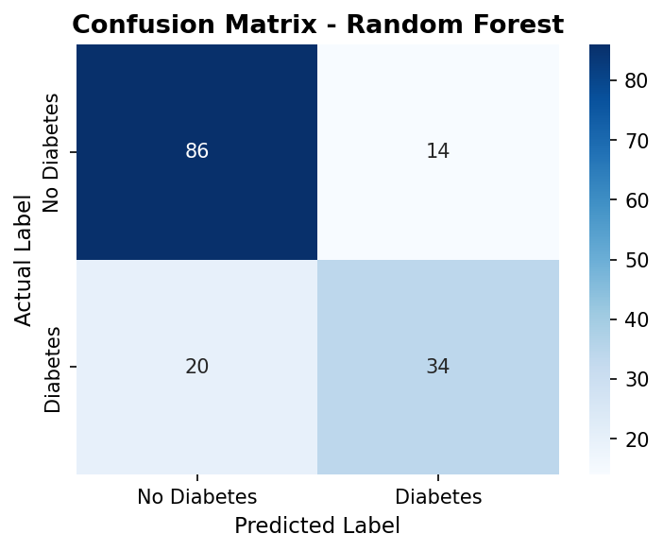

7. Conclusion

The project started with one question: can a machine learning model trained on synthetic data perform well when tested against real patients? The results give a qualified yes. Logistic Regression transferred almost perfectly from synthetic to real, and even Random Forest, which is more sensitive to the details of its training data, still produced a working classifier at 67.53% accuracy on the real test set.
The synthetic data was generated using a very simple method, Gaussian sampling based on per-class means and standard deviations. The fact that it produced these results without any deep learning or specialised libraries shows that even a straightforward statistical approach can be useful. More sophisticated techniques like CTGAN, which is specifically designed for tabular data, would almost certainly close the remaining gap for Random Forest and potentially match or exceed real data performance across both models.
The broader point the project demonstrates is practical. If a simple generation method already produces synthetic data good enough to train a useful classifier, then organisations handling sensitive medical records have a realistic path to sharing data for research purposes without putting any real patient's information at risk. The synthetic records carry the statistical patterns but not the individual stories.
From an academic standpoint the project also brought together most of the STAIML lab curriculum into one end-to-end workflow, which made the individual experiments feel considerably more concrete. Next steps from here would be testing CTGAN for generation, adding statistical distance metrics to quantify how close the distributions actually are, and evaluating more model types to get a fuller picture of how synthetic training data performs across different algorithmic approaches.

8. References
[1] N. Baowaly, C. C. Lin, C.-L. Liu, and K.-T. Chen, "A Systematic Review of Synthetic Data Generation Techniques Using Generative AI," Electronics, vol. 13, no. 17, p. 3509, Sep. 2024, doi: 10.3390/electronics13173509. [Online]. Available: https://www.mdpi.com/2079-9292/13/17/3509

[2] A. Bauer, S. Trapp, M. Stenger, R. Leppich, S. Kounev, M. Leznik, K. Chard, and I. Foster, "Comprehensive Exploration of Synthetic Data Generation: A Survey," arXiv preprint arXiv:2401.02524, Feb. 2024. [Online]. Available: https://arxiv.org/abs/2401.02524

[3] X. Guo and Y. Chen, "Generative AI for Synthetic Data Generation: Methods, Challenges and the Future," arXiv preprint arXiv:2403.04190, Mar. 2024. [Online]. Available: https://arxiv.org/abs/2403.04190

[4] Y. Lu et al., "Machine Learning for Synthetic Data Generation: A Review," arXiv preprint arXiv:2302.04062, updated Apr. 2025. [Online]. Available: https://arxiv.org/abs/2302.04062

[5] J. W. Smith, J. E. Everhart, W. C. Dickson, W. C. Knowler, and R. S. Johannes, "Using the ADAP Learning Algorithm to Forecast the Onset of Diabetes Mellitus," in Proc. Symp. Comput. Appl. Med. Care, 1988, pp. 261-265. (Original Pima Indians Diabetes Dataset source)

